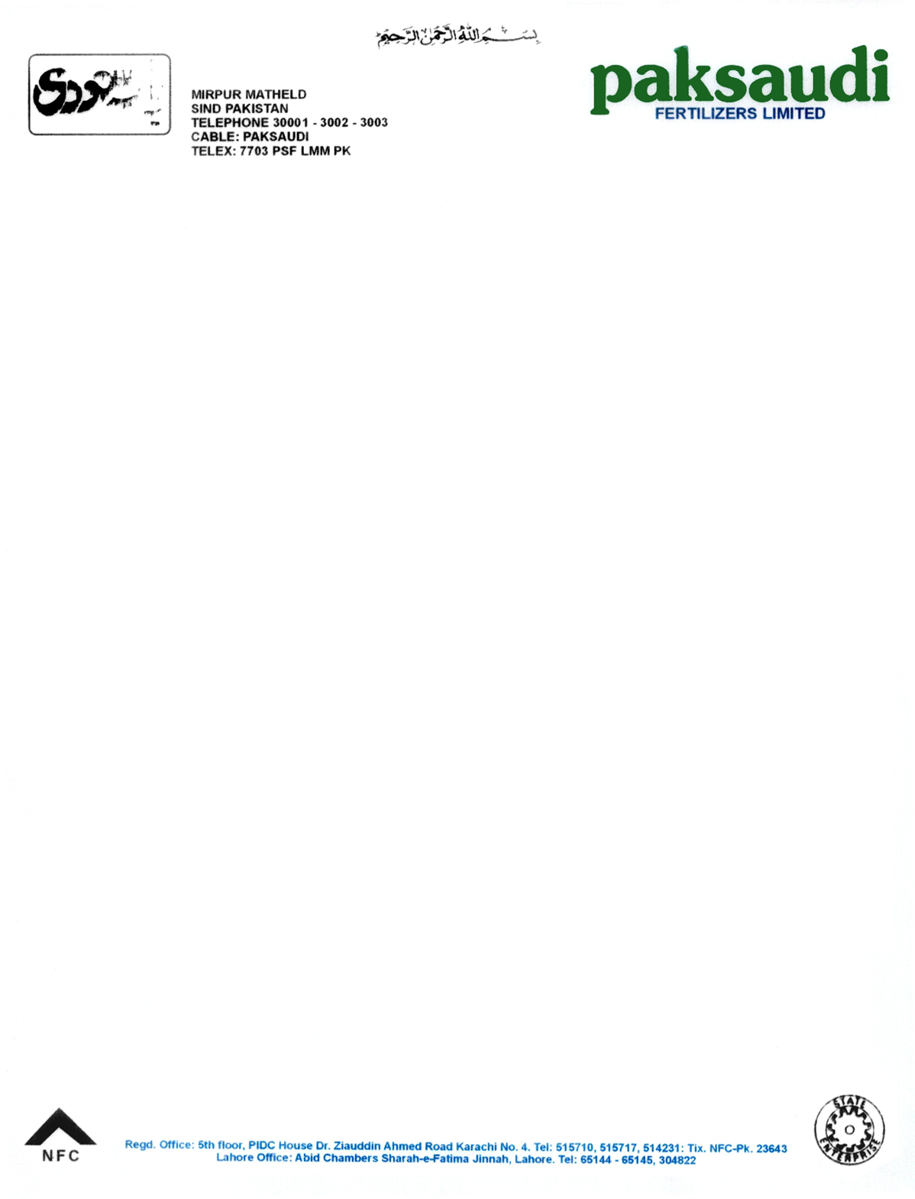

Experience Letter

This is to certify that Mr. <Name> S/o. <fname> has worked with us as <Designation> during Period <From2> To <To2>.

During his work we found him very hardworking and dutiful.

We wish him all best in his future.



**Plant Manager**

**Hassan Khan**